Module 5 - Spring Core and Maven
Exercise 4: Creating and Configuring a Maven Project

Pom.xml:
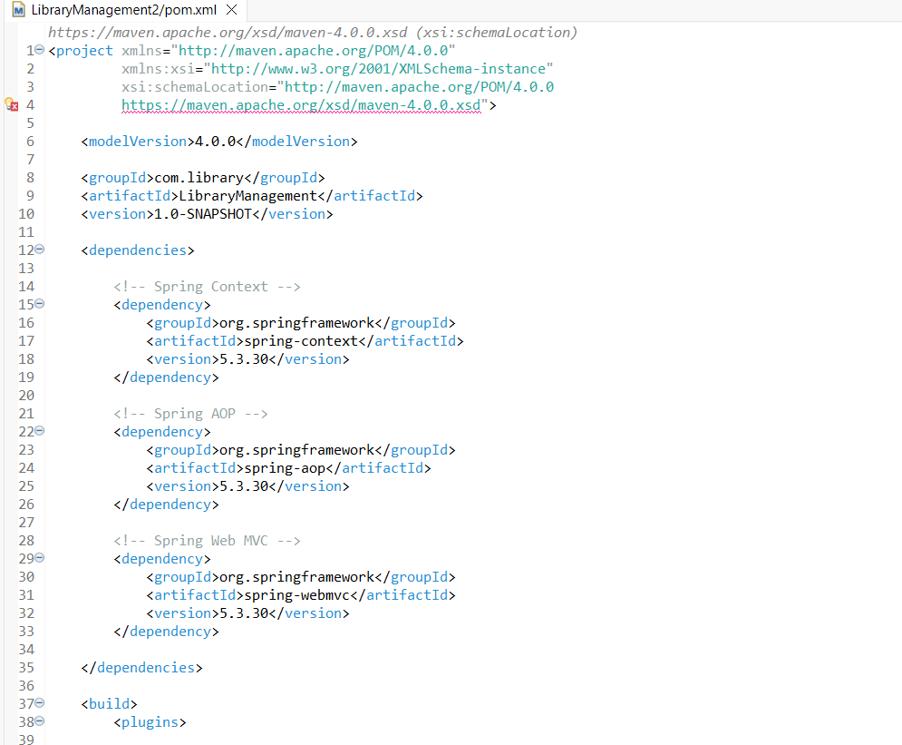
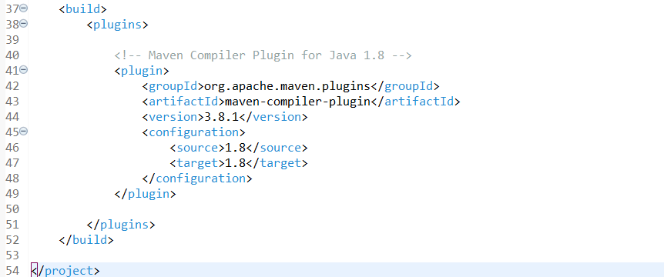

Output/ File Structure:
